# CS 340 README

## About the Project

This project is made to automate the process of creating, reading, updating, and deleting documents in the database.

## Motivation

The animal shelter contains records of over 10,000 animals, which is impossible for one company to keep track of on paper or even in an Excel document. It was necessary to start a project that would promise a faster, easier, and more logical way to organize the thousands of records we had.

## Getting Started

First, if you do not already have a copy, get the most recent version of the aac_shelter_outcomes.csv file and save it to your system. This is the file that contains all of the information and will be read by our program.

Import the csv in your local command prompt or terminal to MongoDB.

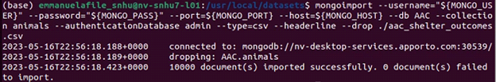

You will then have to make a user account with proper permissions for yourself in the same window. Use the screenshot as an example and write down your username and password to use in Jupyter later.

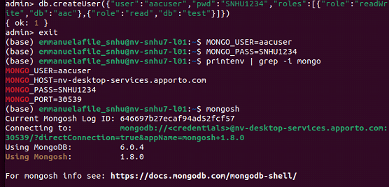

Finally, open Jupyter Notebook and use the given .ipynb files to sign in and start working. Make sure your username, password, host and port are all accurate. If the information is correct, running the Jupyter file should connect you to a local Dash page.

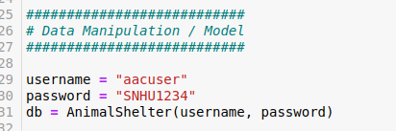



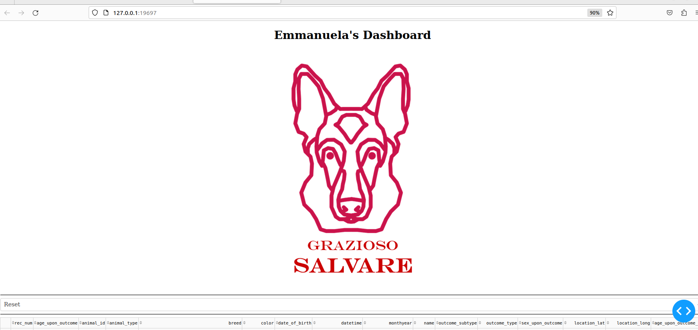

## Installation

* Python: Any Python application works for this project. Use it to take a look at the source code and troubleshoot if necessary, such as editing the port to your preferred one. The best Python recommendation for this particular program is the latest version of Spyder.
* Jupyter Notebook: This is what will be used to create, read, update, and delete any document in the database. You can install it by using [this website](https://jupyter.org/install) which includes the following instructions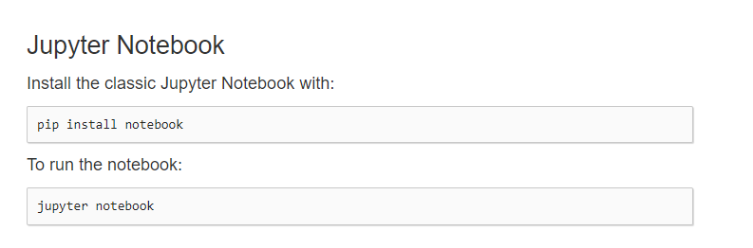
* [MongoDB](https://www.mongodb.com/try/download/community): This is the database where all of the records will be stored. You will also use the mongo shell in your local command prompt or terminal.
* Dash: This is imported into the Jupyter file, but the framework is important to understand. Dash provides the interactive layout that is used for this project. It makes customizing simple and provides many options.

## Usage

### Code Example

This code displays the Grazioso Salvare logo and my unique identifier.

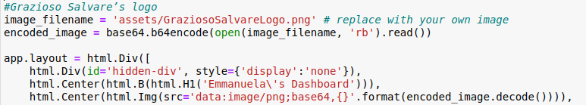

This is the code for the dropdown menu and a peek at how it filters each option.

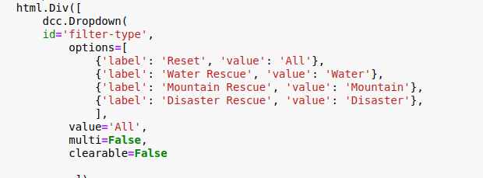

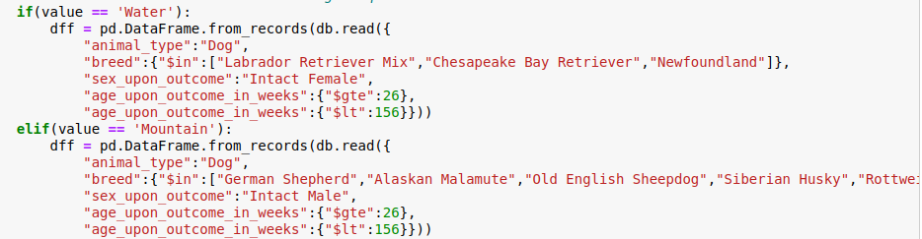  
Screenshots

This screenshot shows the logo, my unique identifier, and the dropdown menu.

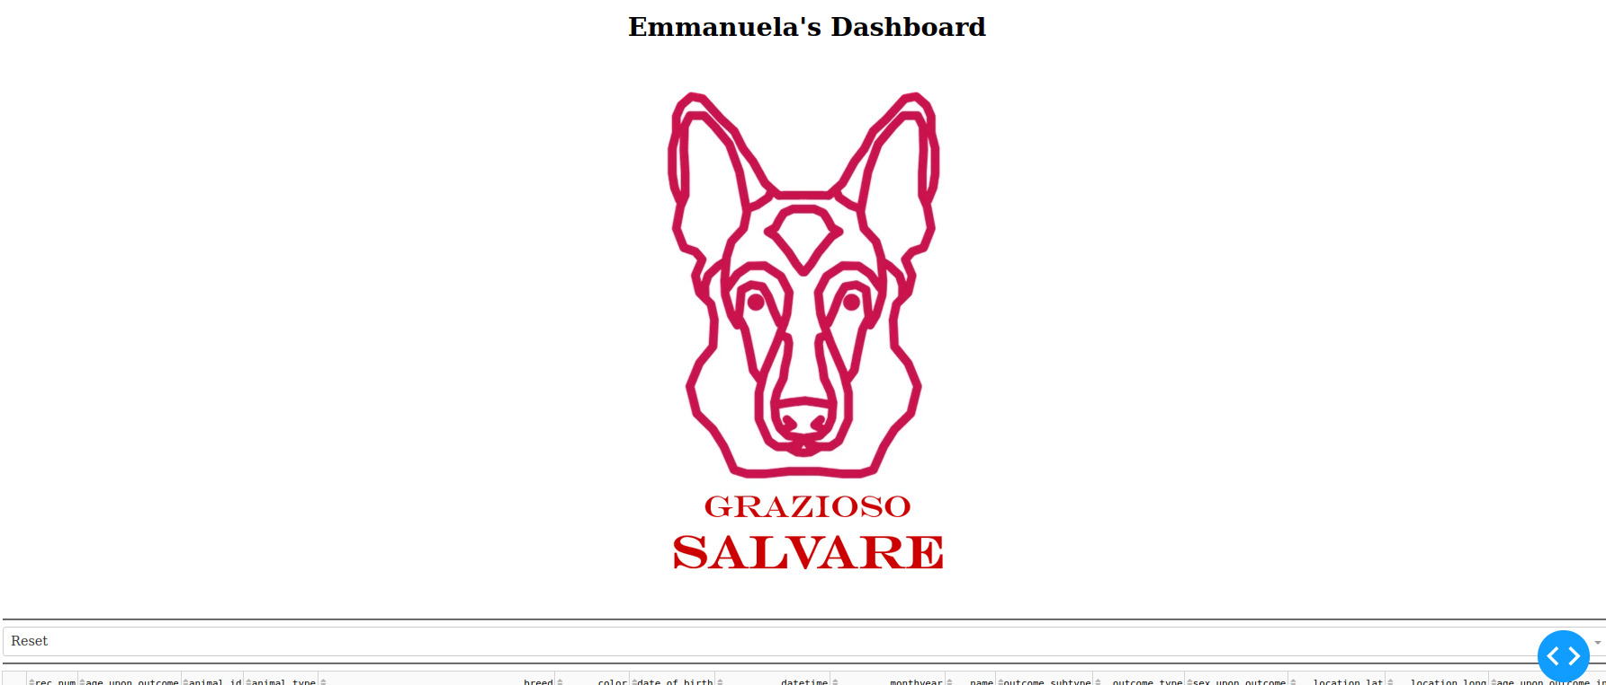

This is what shows up when you choose “Reset”. Every animal is shown, with 10 on each page. The map changes based on the animal that is selected (the left bullet points), and the graph changes based on the dropdown option selected. In this option it shows the proportions of every breed documented in the csv file.

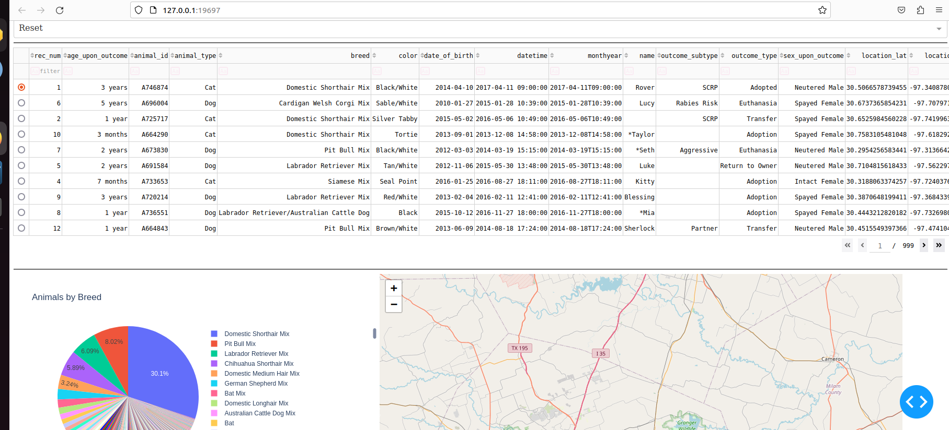

“Water Rescue” option, with map and graph updated automatically.

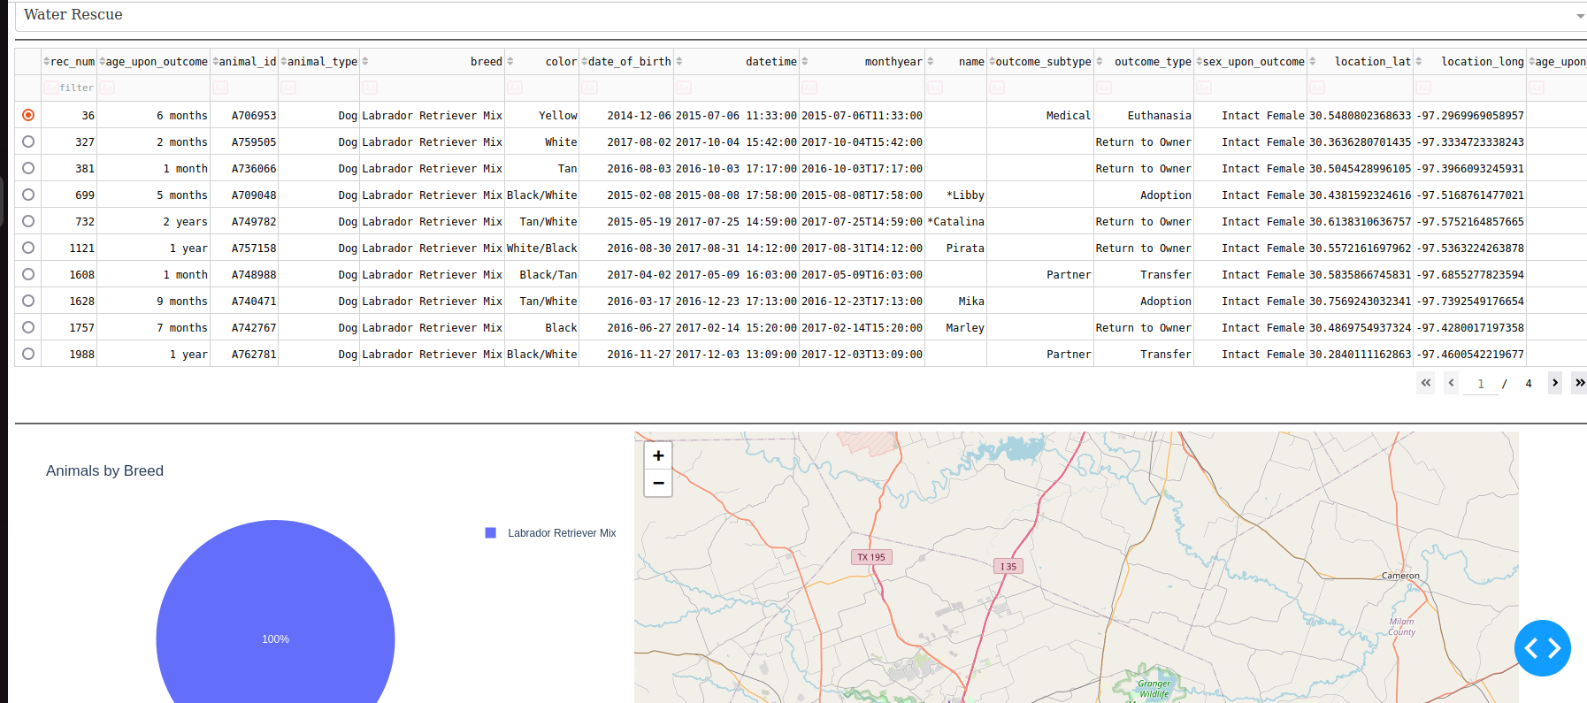

“Mountain Rescue” option.

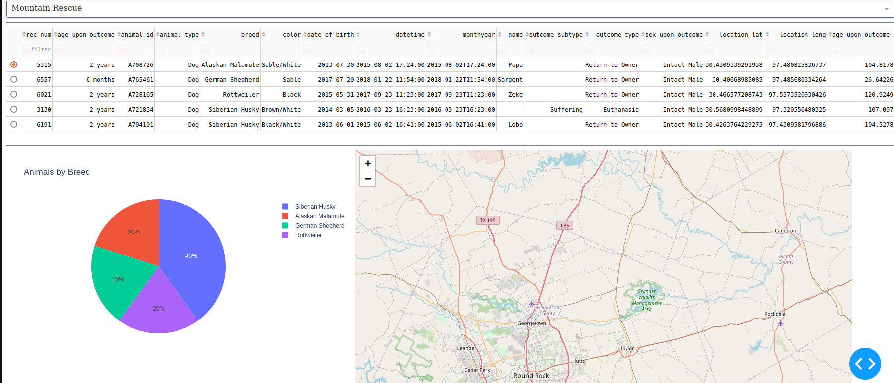

“Disaster Rescue” option.

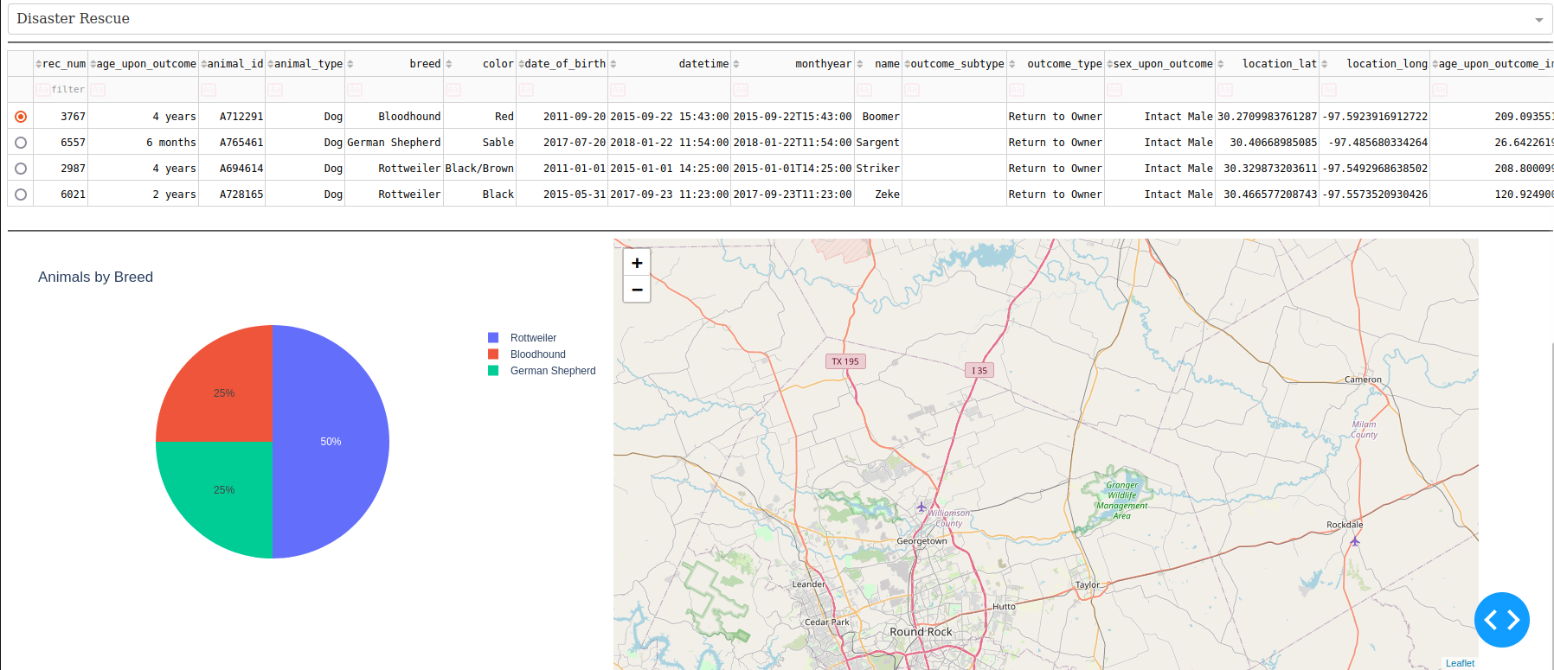

## Contact

Your name: Emmanuela Filev-Mihalak